Pumpkin Shine Entry Form

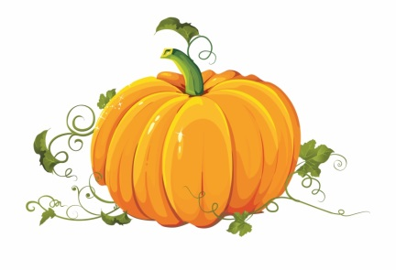

Please complete this form by October 15, 2021. Spots will be assigned at a later date. Drop offs and set ups will take place on Monday, October 18, 2021 and Tuesday, October 19, 2021 from 10 AM – 5 PM only. Removal of your pumpkin must be done by October 22, 2021 by 6:00 pm. Anything left after this point will be disposed of immediately.

For safety reasons, please do not put children’s names on the pumpkins.

Name of Business, Group, School, or Family:

________________________________________________________________________________

Contact Number: _____________________________________________________________

Assigned Spot: ________________________________________________________________

Number of Pumpkins: ________________________________________________________

I agree to the terms and I am responsible for the drop off, set up, and removal of my pumpkin(s) for entry in the Pumpkin Shine 2021 event to be held at the Bossier Parish Library, Plain Dealing Branch.

Name:__________________________________________Signature: _____________________________
(Please print.)

